**ASSIGNMENT 4**



**Fall 2022**

**Object Oriented Programming**

Submitted by: **Abu Bakar**

Registration No. : **21PWCSE2004**

Class Section: **C**

“On my honor, as student of University of Engineering and Technology, I have neither given nor received unauthorized assistance on this academic work.”

Submitted to:

**Dr. Nasruminallah**

January 20, 2023

Department of Computer Systems Engineering

University of Engineering and Technology, Peshawar

**QUESTION # 1:**

**CODE SCREENSHOTS:**

Here are the screenshots of the code.

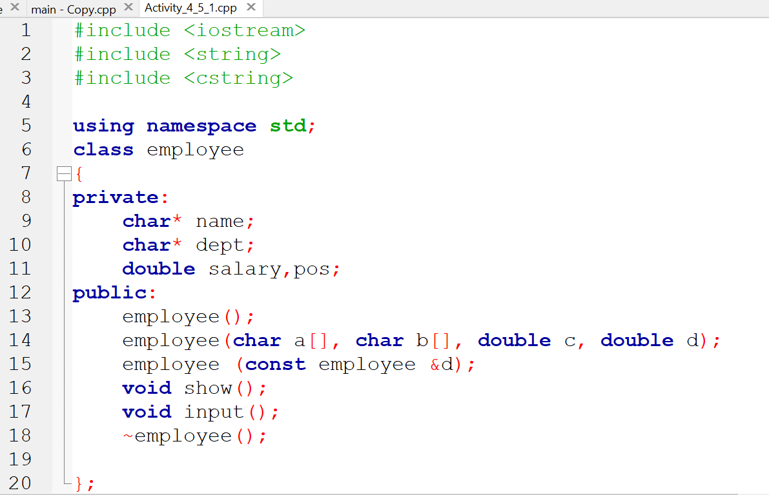

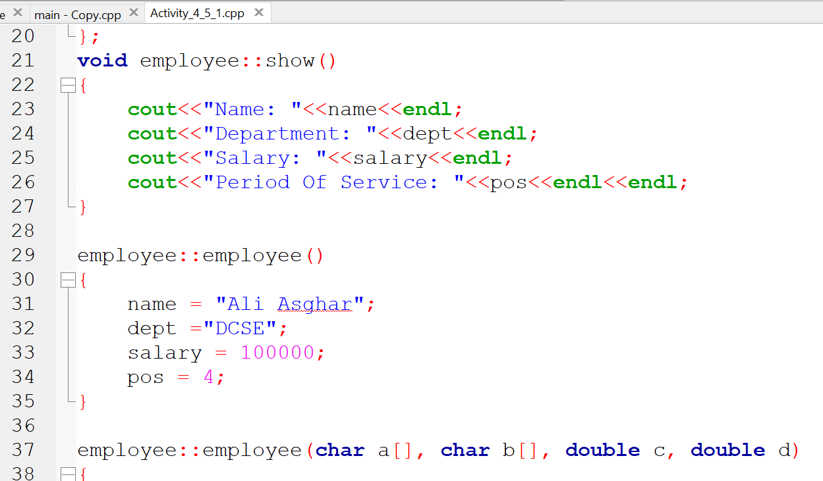

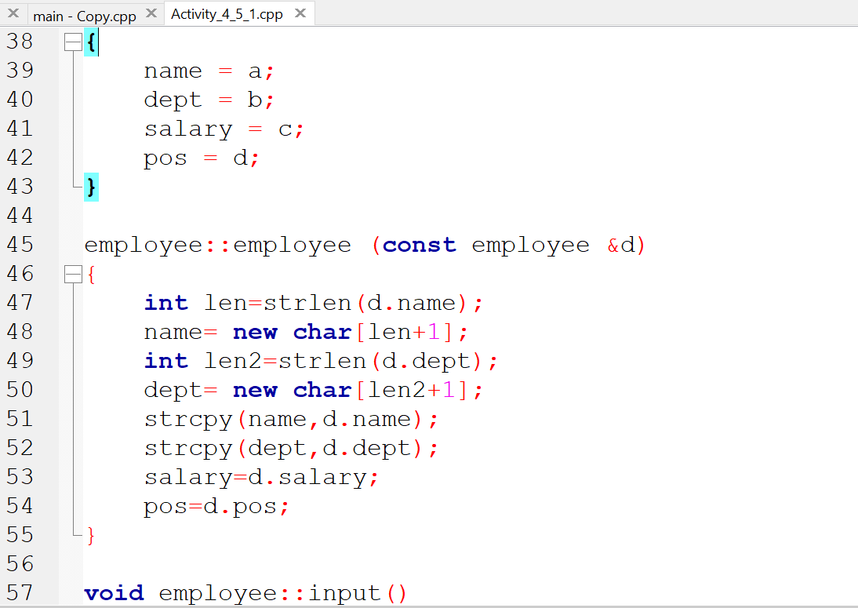

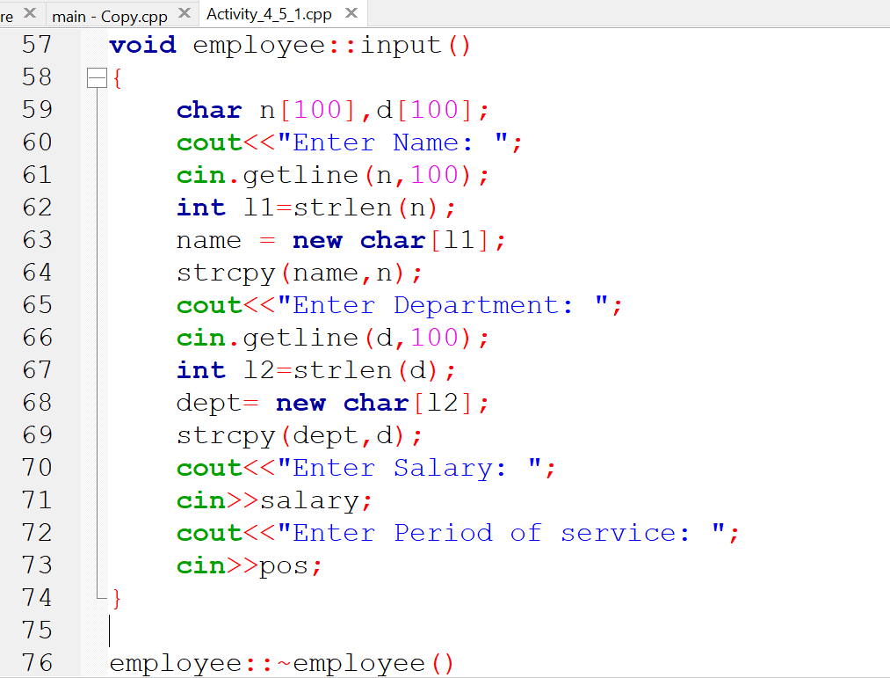

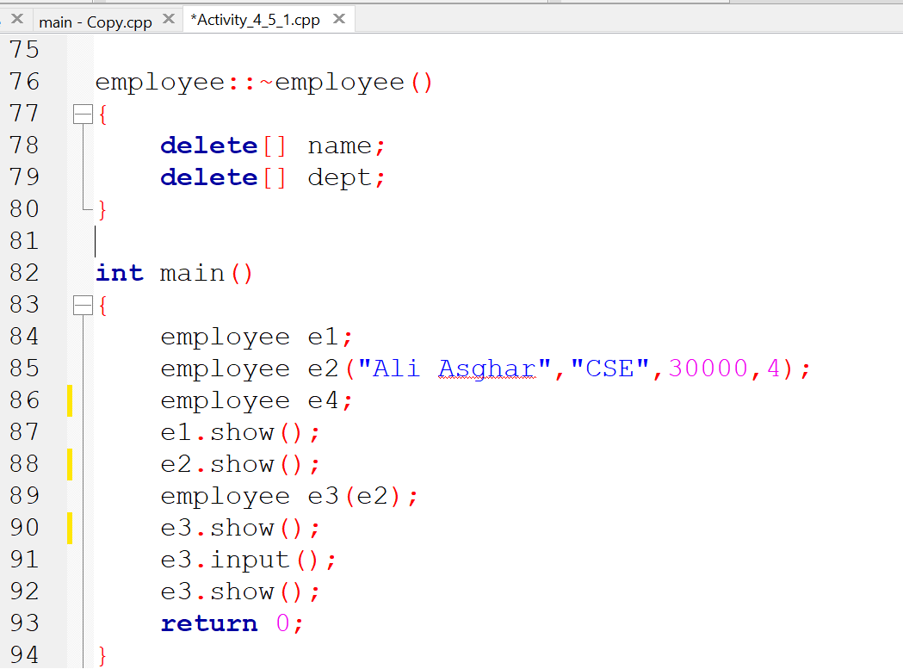

### **OUTPUT (COMPILATION, DEBUGGING & TESTING):**

Here is the screenshot of the output of above code.

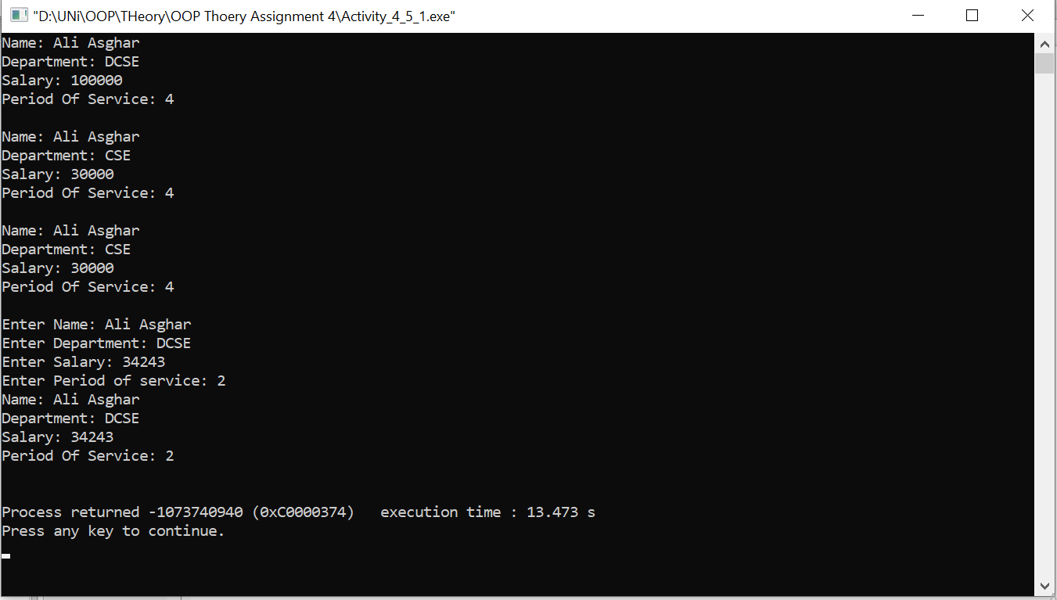

### **IMPLEMENTATION STRATEGY:**

This code defines a class "employee" which represents an employee with private member variables:

* "name" which is a character pointer and stores the name of the employee.
* "dept" which is a character pointer and stores the department of the employee.
* "salary" which is a double and stores the salary of the employee.
* "pos" which is a double and stores the period of service of the employee.

The class has several member functions:

* The default constructor "employee()" which assigns default values to the private member variables.
* The constructor "employee(char a[], char b[], double c, double d)" takes four parameters and assigns them to the private member variables, respectively.
* The copy constructor "employee (const employee &d)" creates a new employee object that is a copy of the passed employee object. It uses the "strcpy" function to copy the name and department strings, and copies the salary and period of service values. The "input()" function prompts the user to enter the name, department, salary and period of service of an employee and assigns the values to the corresponding private member variables.
* The "show()" function displays the values of the private member variables of the employee object.
* The destructor "~employee()" deallocates the memory that was dynamically allocated for the name and department character pointers.

The main function demonstrates the use of all these member functions by creating three employee objects, one with the default constructor, one with the constructor that takes four parameters, and one with the copy constructor. It then calls the "show()" function to display the values of the private member variables of each object, calls the "input()" function for the third object, and calls the "show()" function again to display the updated values of the private member variables.